**SUSTAINABLE ENERGY SOURCES**

**FOR SUSTAINABLE FUTURE**

PROJECT REPORTS

**BTA0183 – BIOLOGY AND ENVIRONMENTAL SCIENCE FOR ENGINEERS WITH CONSERVATION ENGINEERING**

Submitted to

**SAVEETHA INSTITUTE OF MEDICAL AND TECHNICAL SICENCE**

In parcial fulfilment for the award of the degree of

**BACHELOR OF ENINEERING IN**

**ELECTRONICS AND COMMUNICATION**

BY

P. PRATHEESH RAJ REG NO: 192212057

**SUPERVISOR**

DR.S.MOOGAMBIGAI



|  |  |  |
| --- | --- | --- |
| S.NO | CONTENT | PAGE NO |
| 1 | Abstract | 3 |
| 2 | Introduction | 6 |
| 3 | Methodology | 7 |
| 4 | Literature  review | 8 |
| 5 | Results  And  Discussion | 9 |
| 6 | Conclusion | 14 |
| 7 | Reference | 15 |

**TABLE OF CONTENTS**

**1.** ABSTRACT

The pursuit of a bright and prosperous future is intricately linked to the sustainable generation and utilization of energy. This abstract provides a comprehensive overview of sustainable energy sources, emphasizing their potential to create a cleaner, more secure, and brighter future for humanity. We delve into the spectrum of renewable energy resources, such as solar, wind, hydro, and geothermal power, as well as their growing significance in reducing greenhouse gas emissions and mitigating climate change. Additionally, we explore the role of energy storage technologies, energy efficiency measures, and smart grid systems in enhancing the reliability and resilience of sustainable energy sources. The economic and environmental advantages of these sources are discussed, offering a compelling case for their widespread adoption. As we stand at the precipice of pivotal global energy transitions, a focus on sustainable energy sources becomes paramount for a future that is both bright and sustainable.

The global demand for energy continues to rise, prompting a critical need for sustainable and environmentally friendly energy sources. This abstract provides an overview of various energy sources, highlighting their potential as viable solutions for a greener and more sustainable future. We discuss both traditional and emerging energy sources, including fossil fuels, renewable energy, nuclear power, and alternative technologies. The abstract also touches on the environmental and economic implications associated with each energy source. As the world grapples with the challenges of climate change and finite natural resources, understanding the diverse energy options available is crucial for informed decision-making and the transition towards a more sustainable energy landscape.

Safeguarding our energy sources is an imperative in the quest for a sustainable and secure energy future. This abstract provides an overview of the measures and strategies essential for the preservation and protection of both non-renewable and renewable energy sources. We delve into the challenges posed by climate change, geopolitical tensions, and resource depletion, which underline the urgency of energy source protection.

**KEYWORDS:**

Energy sources, renewable energy source, non-renewable energy sources, alternative energy source, environmental impacts, energy economics, importance of energy sources.

**OBJECTIVES:**

* To create awareness about the energy sources.
* To create enough energy sources for future use.
* To create better future.
* To know about renewable energy sources.
* To know about non-renewable energy sources.

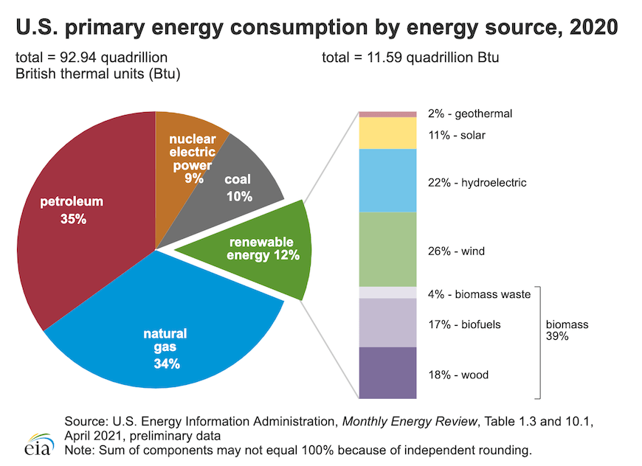

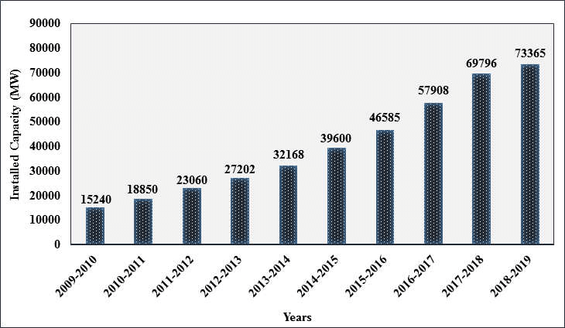

**2.INTRODUCTION:**

* An introduction to energy sources is a fundamental starting point for understanding how our world powers everything from our homes and industries to our transportation systems. Energy sources refer to the various means through which we obtain the energy necessary to fuel our modern lives. These sources can be classified into different categories, each with its unique characteristics, benefits, and challenges.
* The choices we make regarding energy sources have far-reaching implications for the environment, economy, and global stability. From traditional fossil fuels like coal, oil, and natural gas to the rapidly advancing realm of renewable energy options such as solar, wind, and hydropower, the landscape of energy production is continuously evolving.
* In this presentation, we will delve into the diverse array of energy sources, exploring their attributes, impacts, and potential for a sustainable and resilient energy future. We will discuss the advantages and drawbacks of each source, the technologies involved, and the critical role they play in shaping the world's energy landscape.
* By the end of this presentation, you will have a deeper understanding of the various energy sources that power our world and the ongoing efforts to transition towards cleaner, more sustainable alternatives. Join us as we embark on a journey through the world of energy sources and their profound impact on our lives and the planet.

**TYPES OF ENERGY SOURCES:**

* RENEWABLE ENERGY SOURCES
* NON-RENEWABLE ENERGY SOURCES

**RENEWABLE ENERGY SOURCES;**

Renewable energy sources represent a beacon of hope in the quest for a sustainable and environmentally responsible future. Unlike finite fossil fuels, renewable energy derives from inexhaustible natural processes, such as sunlight, wind, and water currents. Harnessing these sources to generate electricity and power our society not only reduces greenhouse gas emissions but also lessens our dependence on fossil fuels. In this introduction, we will explore the marvels of renewable energy, its various forms, and the transformative potential it holds in the global transition towards cleaner, greener, and more sustainable energy solutions.

**NON-RENEWABLE ENERGY SOURCES**:

Non-renewable energy sources, in stark contrast to renewables, are finite and exhaustible reservoirs of energy that have powered our world for generations. These sources primarily include fossil fuels like coal, oil, and natural gas, along with nuclear energy. While they have been essential for modern civilization, their use comes with significant environmental and geopolitical challenges. In this presentation, we will delve into the characteristics of non-renewable energy sources, their historical significance, and the pressing need to explore cleaner and more sustainable alternatives for a more secure and environmentally responsible energy future.

**2.METHADOLOGY**

* A survey has been conducted to know about people knowledge over energy sources for sustainable future.
* In this survey, the response had got more than 70 from over college friends and family members of are taken (or) recorded.
* The response has been analyzed statistically. By using SPSS software created bar graphs to get the statistical values.
* To data which is present on the survey can be taken correctively. The following are the question that given to the survey.

**3.LITERATURE REVIEW**

**Solar Energy**

Power generation through renewable energy sources is the need of the hour as we cannot be only dependent on the conventional energy sources to meet our needs. Solar energy is one of the most important renewable energy sources used all over the world [22]. Solar panels make use of the solar radiation reaching to the Earth and help in generating electric power with the help of solar radiation [23]. This power is utilized by us, in our households, industries, offices, schools, colleges, etc [24]. Solar panels are made up of solar modules connected in parallel; the solar modules are comprised of solar cells connected in series. Each solar cell is made up of a semiconductor like silicon, germanium, etc. Each solar cell acts as a PN junction and when the photon particles hit the surface of the solar panel then current flows due to the Photovoltaic effect. The output of the solar panels is dc in nature; hence the output can be connected to an inverter which converts DC to AC and then this AC power can be used to run the electrical appliances used in our house. The excess AC power can be provided to the grid [23].

**Wind Energy**

Wind energy is one of the purest forms of renewable energy source and many developed countries have made several energy policies to develop electrical power from wind energy to meet their needs. The mechanism of developing electric power using wind energy is also very simple but the only disadvantage is the Wind Energy Conversion System depends on the wind energy which is very uncertain and it is very difficult to get the desired output [12]. The wind turbine rotates due to the wind energy; the mechanical energy of the wind turbine is fed to the generator through a gear box. Gear box helps in maintaining same speed for the turbine and synchronous generator. The output of the generator is AC in nature; mainly Permanent Magnet Synchronous Generator is used. The output of the generator is fed to some power electronics converter which can be either multilevel converter or Matrix converter or Z source converter. The final output can be transmitted and distributed to domestic consumers, industrial and commercial consumers. Thus, wind energy can play a significant role in the meeting the energy needs [12].

**Geo-Thermal Energy**

Geothermal energy is the thermal energy generated and stored in earth. This is the energy that determines the temperature of matter. It originates from the original formation of earth and through radioactive decay of the materials [28]. Water from hot springs is used since early times, but now it is used for electricity generation [29]. It is cost-effective, reliable, environmental friendly. But is limited only to areas near the tectonic plates [30]. There are three types of geothermal energy are there those are called: liquid-dominated plants, geothermal energy.

**4.RESULT AND DISCUSSION**

|  |
| --- |
| Forms response chart. Question title: 1.Which of the following is considered as renewable energy source?. Number of responses: 68 responses. |

FIGURE 1: PEPOPLE AWARENESS ABOUT RENEWABLE SOURCES

Through this figure we come to know that nearly 44.1% of people said that wind is renewable energy source and 35.3% and 20.6% were natural gas and coal, said by people. So, most of the people have knowledge about renewable energy source.

|  |
| --- |
| Forms response chart. Question title: 2.What is the primary source of energy for electricity generation in your region?. Number of responses: 68 responses. |

FIGURE 2: PEOPLE KNOWLEDGE ON SOURCE FOR ELECTRICITY GENERATION

Nearly half of the people 39.7% said that renewable sources are the primary sources of energy for electricity generation in their region.27.9 % are natural gas, 22.1% are nuclear and 10.3 % are coal. So, the renewable resources play the major role in day to day life.

|  |
| --- |
| Forms response chart. Question title: 3.Which energy sources is associated with the term "fracking"?. Number of responses: 68 responses. |

Figure 3: energy source associated with the term “fracking”.

We can see here, that natural gas is the correct answer. 23.5% people have knowledge on that. Majority of the persons chose geothermal (39.7%).20.6 people have chosen the biomass and 16.2% were solar.

|  |
| --- |
| Forms response chart. Question title: 4.Which renewable sources converts light into electricity? . Number of responses: 64 responses. |

Figure 4: people knowledge about renewable resource that converts light into electricity

We can see that half of the people (50%) said that solar energy converts light into electricity.15.6% selected hydroelectric. 17.2 selected tidal and 17.2 selected wind energy. So, people have good knowledge on solar energy.

|  |
| --- |
| Forms response chart. Question title: 5.Which energy sources is known for producing the least amount of green house gas emissions?. Number of responses: 66 responses. |

Figure 5: people knowledge on greenhouse gas emissions.

We can see that 420.4% people said that natural gas is the energy source that produces least amount of greenhouse gas emissions. 21.2% people said the correct answer – nuclear. 15.2% selected wind and 21.2 selected coal.

|  |
| --- |
| Forms response chart. Question title: 6.What is the most abundant greenhouse gas emitted from burning fossil fuels?. Number of responses: 65 responses. |

Figure 6: people knowledge about gas that emitted from burning fossil fuels.

Carbon dioxide (CO2) is the green house that gas that emitted from burning fossil fuels.23.1% said the correct answer. The majority is methane (CH4) 38.5%. 30.8% people selected nitrous oxide (N2O) and 7.7% people have selected the ozone (O3).

|  |
| --- |
| Forms response chart. Question title: 7.Which energy sources involves the splitting of atoms to generate power?. Number of responses: 63 responses. |

Figure 7: people knowledge about splitting of atoms to generate power

We can see that majority (58.7%) of the people have selected the nuclear Power. They said that nuclear is the energy source that generates power by splitting the atoms. 19% people selected hydroelectric. 14.3% people said wind and 7.9% people said solar energy.

|  |
| --- |
| Forms response chart. Question title: 8.Which fossil fuel is responsible for the highest carbon dioxide emissions when burned for energy?. Number of responses: 63 responses. |

Figure 8: people knowledge on fossil fuels.

31.7% people said that natural gas is responsible for CO2 emissions when burned foe energy.33.3 % people said the correct answer coal. 28.6 % people said oil and 6% selected the peat, interesting!

|  |
| --- |
| Forms response chart. Question title: 9.Which non renewable energy source is primarily used in nuclear power plants? . Number of responses: 64 responses. |

Figure 9: people awareness on nuclear power plants

We can see that 45.3% of the people said that uranium is the non-renewable energy source that which is primarily used in nuclear power plants.25% said that coal. 20.3% people said that natural has and 9.4% of the people said that oil.

|  |
| --- |
| Forms response chart. Question title: 10.What is the main component of natural gas?. Number of responses: 64 responses. |

Figure 10: main component of natural gas

We can see that 42.2% of the people said that methane is the main component of natural gas. 31.3 % of the people said that ethane .21.9% of the people said that propane and 3 % of the people said butane

**5. CONCLUSION:**

“Our exploration of various energy sources highlights the diverse options available to meet our energy needs while addressing the challenges of sustainability, environmental impact, and climate change. We've learned that no single energy source is a silver bullet, but a combination of sources and innovative technologies is the key to a cleaner and more sustainable energy future.

* Renewable energy sources like solar, wind, and hydroelectric power offer environmentally friendly alternatives with the potential to reduce our carbon footprint significantly. They are essential components of a sustainable energy mix.
* Nuclear energy, despite its challenges and concerns, offers a low-carbon and high-capacity option that can contribute to the reduction of greenhouse gas emissions.
* Fossil fuels, on the other hand, continue to provide a significant portion of our energy needs but come with environmental and climate drawbacks. Transitioning away from them and exploring carbon capture and storage technologies is crucial.
* Efficiency improvements and advancements in energy storage technologies are pivotal in making the most of all energy sources and ensuring a reliable and resilient energy system.

Our choices today will shape the energy landscape of tomorrow, affecting not only our well-being but the health of our planet. It is our collective responsibility to make informed decisions and support the development and adoption of greener and more sustainable energy solutions. Let's embrace a future where clean, affordable, and abundant energy sources power our world while preserving it for generations to come. Thank you for your attention.”

**SUGGESTION:**

We are using large amount of energy sources in our life. It is very hard to run the world without the energy sources. Our world runs because of the energy sources. So, we should think that we have limit amount of non-renewable energy sources and excess of renewable source. So, we should use that correctly and we should not waste that.

**ACKNOWLEDGEMENT:**

This survey and report are done by P. Pratheesh Raj from ECE department for the subject of Biological and Environmental Sciences for engineering to Saveetha Institute of Medical and Technical Sciences, Chennai under the supervision of Dr S.Moogambigai and thanking her on helping us to prepare a report on sustainable energy sources for sustainable future.

**6.REFERENCE**

1. https://www.acciona.com/renewable-energy/
2. https://www.goodrenergy.co.uk/how-do-solar-panels-work/
3. Mendi, Vikas & Rao, Subba & SEELAM, JAYA. (2016). Tidal Energy: A Review.Tousif, Shaikh Md Rubayiat, and Shaiyek Md Buland Taslim. "Tidal power: an effective method of generating power." International Journal of Scientific & Engineering Research 2, no. 5 (2011): 1-5.
4. Kumar, Arun & Schei, Tormod & Ahenkorah, Alfred & Rodriguez, R & Devernay, Jean-Michel & Freitas, Marcos & Hall, Douglas & Killingtveit, Ã…nund & Liu, Z. (2012). Hydropower.
5. Dye, S. T. (2012). "Geoneutrinos and the radioactive power of the Earth". Reviews of Geophysics. 50 (3): RG3007. arXiv:1111.6099(https://arxiv.org/abs/1111.6099).Bibcode:2012RvG eo.50.3007D(https://ui.adsabs.harvard.edu/abs/2012RvGeo..50.3007 D).doi:10.1029/2012RG000400(https://doi.org/10.1029%2F2012RG0 00400).S2CID118667366 (https://api.semanticscholar.org/CorpusID:118667366).
6. REN21. "Renewables 2020: Global Status Report. Chapter 01; Global Overview" ([https://www.ren21.net/g sr-2020](https://www.ren21.net/g%20sr-2020)). Retrieved 2021-02-02.
7. Glassley, William E. (2010). Geothermal Energy: Renewable Energy and the Environment, CRC Press, ISBN9781420075700.
8. Geothermal Economics 101, Economics of a 35 MW Binary Cycle Geothermal Plant (https://web.archive.org/web/20100501143651/http://www.glacierpar tnerscorp.com/geothermal.php), New York: Glacier Partners, October 2009, archived from the original (http://www.glacierpartnerscorp.com/geothermal.php) on 2010-05-01, retrieved 2009-10-17
9. Fridleifsson, Ingvar B.; Bertani, Ruggero; Huenges, Ernst; Lund, John W.; Ragnarsson, Arni; Rybach, Ladislaus (2008-02-11), O. Hohmeyer and T. Trittin (ed.), The possible role and contribution of geothermal energy to the mitigation of climate change | IPCC Scoping Meeting on Renewable Energy Sources conference (https://web.archive.org/web/20100308014920/http://www.ieagia.org/documents/FridleifssonetalIPCCGeothermalpaper2008FinalRybacp 0May08_000.pdf) (PDF), Luebeck, Germany, pp. 5980, archived from the original (http://www.iea- gia.org/documents/FridleifssonetalIPCCGeothermalpaper2008 FinalRybacp0May08_000.pdf) (PDF) on March 8, 2010, retrieved 2009-04-06
10. Rybach, Ladislaus (September 2007). Geothermal Sustainability (http://geoheat.oit.edu/bulletin/bull28-3/art2.pdf) (PDF). Geo-Heat Centre Quarterly Bulletin. 28. Klmath Falls, Oregon: Oregon Institute of Technology. pp. 27. Retrieved 2009-05-09.
11. Webdesign,Insyde."How does biogas work?"(https://web.archive.org/web/20180510115131/http://www.si mgas.com/advantages-of-biogas/how-does-biogas- work/item46) www.simgas.com. Archived from the original (http://www.simgas.com/advantages-of-biogas/how-does-biogas- work/item46) on 10May 2018. Retrieved 16 May 2018.
12. "Biogas & Engines" (http://www.clarke-energy.com/gas- type/biogas/). clarke-energy.com.Retrieved 21 November 2011.